Ideation Phase Empathize & Discover

Date | 30 Januray 2025
Team ID | LTVIP2026TMIDS66306
Project Name | Gemini historical artifact description
Maximum Marks

Empathy Map Canvas:

The Gemini Historical Artifact Empathy Map focuses on understanding the needs, experiences, and motivations of historians, researchers, archivists, and space enthusiasts who interact with artifacts from the Gemini space program. These individuals are deeply committed to preserving and documenting important spacecraft components, mission records, photographs, and astronaut equipment that represent a crucial phase in space exploration history.

Example:

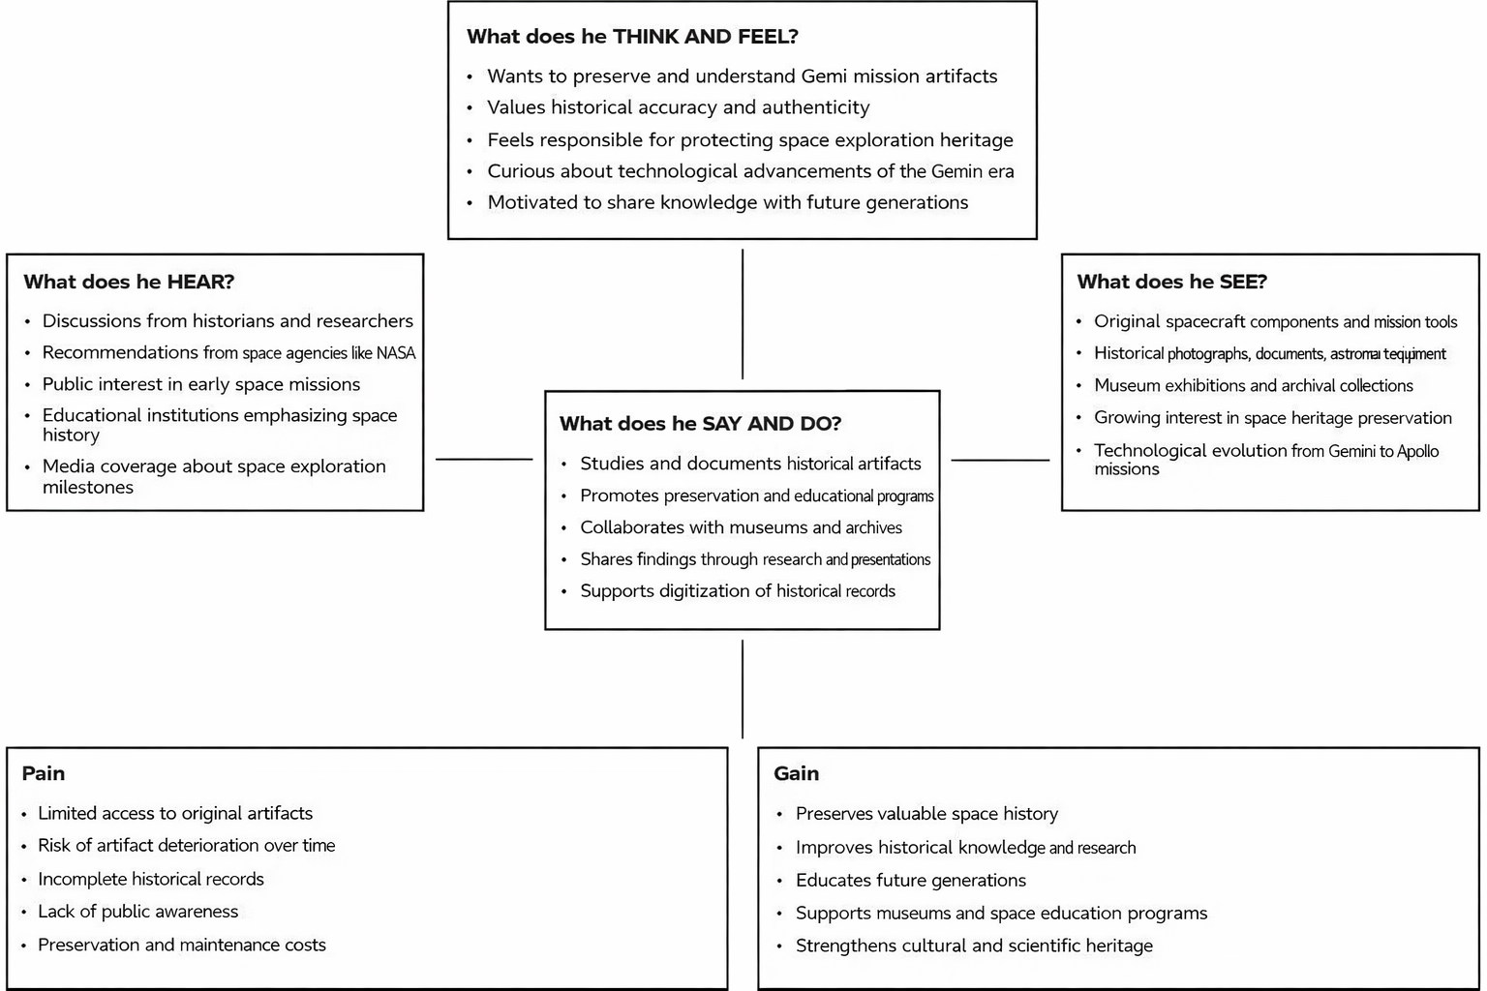

Example: Gemini historical artifact description

